https://blog-gestion-de-projet.com/wp-content/uploads/2020/07/logo-blog2-293px-transparent.png

CMRL Project

**Meeting report**

**Meeting report**

**[Meeting title]**

|  |  |  |
| --- | --- | --- |
| **Owner** |  | |
|  |  |  |
| **Document title and version** |  | |
|  | | |
| **Date and the time of the meeting** | **2022-03-12** | |
|  | | |
| **Project reference** |  | |
|  |  |  |
| **Meeting place** |  | |

|  |  |  |
| --- | --- | --- |
| **Recipients**  **(participants or not)** |  | |
| **Attended the meeting?** | **Owner** | **Service or Company** | | **E-mail** |
| X | Alain DUPOND |  | |  |
|  | François DURAND |  | |  |
| X | Anwar DIMI |  | |  |
| X | Christophe FOLIOT |  | |  |
|  |  |  | |  |
|  |  |  | |  |
|  |  |  | |  |
|  |  |  | |  |
|  |  |  | |  |

**Table of Contents**

Objectives of the meeting 3

Agenda 3

Discussion points 3

*Refer to the action register for the complete list of actions.* 4

Decisions 4

Next meetings 4

## Objectives of the meeting

|  |
| --- |
| **What are the objectives set for this meeting?**  **Why did you gather these members in this place on that day?** |
|  |

## Agenda

|  |
| --- |
| **Previous agenda** |
| Subject 1  Subject 2  Subject 3  Subject 4 |

## Discussion points

|  |
| --- |
| **Subjects discussed in the meeting** |
| **Subject 1**  Summary of discussions, remarks  Conclusions and decisions are taken where applicable  **Subject 2**  Summary of discussions, remarks  Conclusions and decisions are taken where applicable  **Subject 3**  Summary of discussions, remarks  Conclusions and decisions are taken where applicable  **Subject 4**  Not addressed due to lack of time |

**Actions**

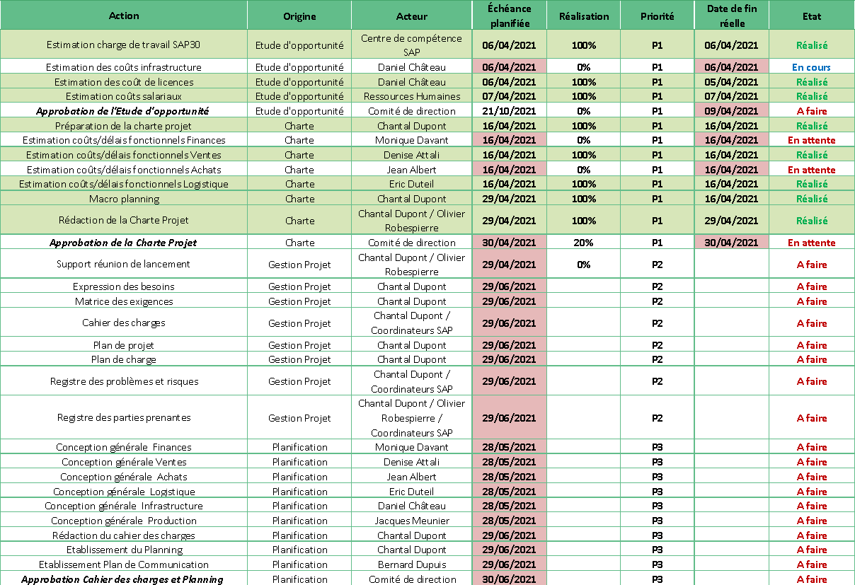

## *Refer to the action register for the complete list of actions.*

## Decisions

|  |
| --- |
| **Taken decisions and recommendations** |
| * Effectiveness, achievement of meeting objectives * Agenda points are tracked * Environment, particular difficulties related to the organization, areas for improvement, etc. |

## Next meetings

|  |
| --- |
| **Dates and places of the next meetings if they have been defined** |
|  |